Example 3 Goodness of Fit Measures Logistic Regression
Singh
##Read the Example 3 data
library(readxl)
## Warning: package 'readxl' was built under R version 4.3.3
uisdat <- read_excel("C:/Users/Pradeep Singh/Documents/Professional/CSDA5110/Fall_2024/Week6/logistic regression/logistic regression/UMARU.xlsx")
View(uisdat)
head(uisdat)
## # A tibble: 6 × 9
## ID Age BECK IVHX NDRUGTX Race Treat Site DFREE
## <dbl> <dbl> <dbl> <dbl> <dbl> <dbl> <dbl> <dbl> <dbl>
## 1 1 39 9 3 1 0 1 0 0
## 2 2 33 34 2 8 0 1 0 0
## 3 3 33 10 3 3 0 1 0 0
## 4 4 32 20 3 1 0 0 0 0
## 5 5 24 5 1 5 1 1 0 1
## 6 6 30 32.6 3 1 0 1 0 0

Deviance as a Goodness-of-Fit for Logistic Regression
library(api2lm)
library(aod)
library(MASS)
intercept_Model <- glm(DFREE~ 1, family=binomial, uisdat)
full_model <- glm(DFREE~ Age+BECK+IVHX+NDRUGTX+Race+Treat+Site, family=binomial, uisdat)
summary(full_model)
##
## Call:
## glm(formula = DFREE ~ Age + BECK + IVHX + NDRUGTX + Race + Treat +
## Site, family = binomial, data = uisdat)
##
## Coefficients:
## Estimate Std. Error z value Pr(>|z|)
## (Intercept) -1.9991800 0.5879337 -3.400 0.000673 ***
## Age 0.0482398 0.0172169 2.802 0.005080 **
## BECK 0.0004193 0.0107988 0.039 0.969030
## IVHX -0.3699491 0.1283375 -2.883 0.003944 **
## NDRUGTX -0.0617824 0.0257134 -2.403 0.016273 *
## Race 0.2296271 0.2229677 1.030 0.303072
## Treat 0.4292549 0.1985299 2.162 0.030605 *
## Site 0.1212729 0.2152053 0.564 0.573080
## ---
## Signif. codes: 0 '***' 0.001 '**' 0.01 '*' 0.05 '.' 0.1 ' ' 1
##
## (Dispersion parameter for binomial family taken to be 1)
##
## Null deviance: 653.73 on 574 degrees of freedom
## Residual deviance: 620.09 on 567 degrees of freedom
## AIC: 636.09
##
## Number of Fisher Scoring iterations: 4
pchisq(full_model$deviance,full_model$df.residual,lower=FALSE)
## [1] 0.06062107
anova(full_model,test="Chisq")
## Analysis of Deviance Table
##
## Model: binomial, link: logit
##
## Response: DFREE
##
## Terms added sequentially (first to last)
##
##
## Df Deviance Resid. Df Resid. Dev Pr(>Chi)
## NULL 574 653.73
## Age 1 1.3980 573 652.33 0.237052
## BECK 1 0.5687 572 651.76 0.450788
## IVHX 1 18.1528 571 633.61 2.039e-05 ***
## NDRUGTX 1 7.3027 570 626.31 0.006885 **
## Race 1 1.2209 569 625.09 0.269187
## Treat 1 4.6775 568 620.41 0.030561 *
## Site 1 0.3159 567 620.09 0.574109
## ---
## Signif. codes: 0 '***' 0.001 '**' 0.01 '*' 0.05 '.' 0.1 ' ' 1
##Using the difference in deviance and associated p-value
library(api2lm)
library(aod)
library(MASS)
intercept_Model <- glm(DFREE~ 1, family=binomial, uisdat)
full_model <- glm(DFREE~ Age+BECK+IVHX+NDRUGTX+Race+Treat+Site, family=binomial, uisdat)
full_model$null.deviance-full_model$deviance
## [1] 33.63644
pchisq(full_model$null.deviance-full_model$deviance,7,lower=FALSE)
## [1] 2.014321e-05
anova(intercept_Model, full_model, test = "LRT")
## Analysis of Deviance Table
##
## Model 1: DFREE ~ 1
## Model 2: DFREE ~ Age + BECK + IVHX + NDRUGTX + Race + Treat + Site
## Resid. Df Resid. Dev Df Deviance Pr(>Chi)
## 1 574 653.73
## 2 567 620.09 7 33.636 2.014e-05 ***
## ---
## Signif. codes: 0 '***' 0.001 '**' 0.01 '*' 0.05 '.' 0.1 ' ' 1
##Pearson Goodness of Fit Measure
print(paste("Pearson's X^2 =",round(sum(residuals(full_model,type="pearson")^2),3)))
## [1] "Pearson's X^2 = 578.94"
1-pchisq(579.198, df=567)
## [1] 0.3521857
##Hosmer-Lemeshow Tests
library(ResourceSelection)
## ResourceSelection 0.3-6 2023-06-27
library(PredictABEL)
library(performance)
uisdat <- as.data.frame(uisdat)
lm1 <- hoslem.test(uisdat$DFREE, fitted(full_model), g = 10)
lm1
##
## Hosmer and Lemeshow goodness of fit (GOF) test
##
## data: uisdat$DFREE, fitted(full_model)
## X-squared = 4.7002, df = 8, p-value = 0.7891
lm2 <- performance_hosmer(full_model, n_bins = 10)
lm2
## # Hosmer-Lemeshow Goodness-of-Fit Test
##
## Chi-squared: 4.700
## df: 8
## p-value: 0.789
## Summary: model seems to fit well.
plotCalibration(data = uisdat, cOutcome =9 , predRisk = fitted(full_model), groups= 10)
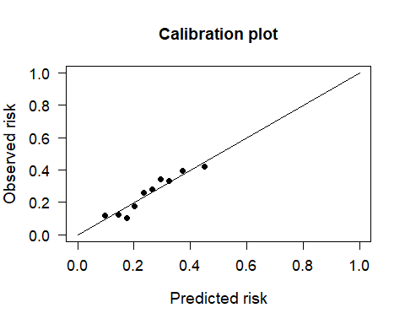
## $Table_HLtest
## total meanpred meanobs predicted observed
## [0.0256,0.125) 58 0.096 0.121 5.54 7
## [0.1253,0.160) 57 0.146 0.123 8.31 7
## [0.1603,0.191) 58 0.175 0.103 10.13 6
## [0.1913,0.219) 57 0.203 0.175 11.59 10
## [0.2194,0.250) 58 0.235 0.259 13.61 15
## [0.2498,0.280) 57 0.266 0.281 15.14 16
## [0.2798,0.306) 58 0.294 0.345 17.05 20
## [0.3059,0.343) 57 0.323 0.333 18.42 19
## [0.3433,0.405) 58 0.371 0.397 21.54 23
## [0.4047,0.576] 57 0.451 0.421 25.68 24
##
## $Chi_square
## [1] 4.335
##
## $df
## [1] 8
##
## $p_value
## [1] 0.8257

classification
library(ResourceSelection)
library(PredictABEL)
library(performance)
library(dplyr)
##
## Attaching package: 'dplyr'
## The following object is masked from 'package:MASS':
##
## select
## The following objects are masked from 'package:stats':
##
## filter, lag
## The following objects are masked from 'package:base':
##
## intersect, setdiff, setequal, union
library(stargazer)
##
## Please cite as:
## Hlavac, Marek (2022). stargazer: Well-Formatted Regression and Summary Statistics Tables.
## R package version 5.2.3. https://CRAN.R-project.org/package=stargazer
library(caret)
## Loading required package: ggplot2
## Loading required package: lattice
library(pROC)
## Type 'citation("pROC")' for a citation.
##
## Attaching package: 'pROC'
## The following objects are masked from 'package:stats':
##
## cov, smooth, var
uisdat$prob_fitted <- predict(full_model,uisdat, type="response")
pred_class <- ifelse(uisdat$prob_fitted > 0.5, "1", "0")
observed_class <- uisdat$DFREE
mean(pred_class ==observed_class)
## [1] 0.7391304
class_fitted <- cbind(observed_class, pred_class)
pred_tab <- table(observed_class, pred_class)
confusionMatrix(pred_tab)
## Confusion Matrix and Statistics
##
## pred_class
## observed_class 0 1
## 0 422 6
## 1 144 3
##
## Accuracy : 0.7391
## 95% CI : (0.7012, 0.7746)
## No Information Rate : 0.9843
## P-Value [Acc > NIR] : 1
##
## Kappa : 0.0092
##
## Mcnemar's Test P-Value : <2e-16
##
## Sensitivity : 0.74558
## Specificity : 0.33333
## Pos Pred Value : 0.98598
## Neg Pred Value : 0.02041
## Prevalence : 0.98435
## Detection Rate : 0.73391
## Detection Prevalence : 0.74435
## Balanced Accuracy : 0.53946
##
## 'Positive' Class : 0
##

ROC curve
library(dplyr)
library(stargazer)
library(caret)
library(pROC)
library(ggplot2)
library(ResourceSelection)
library(PredictABEL)
library(performance)
roc1 <- roc(uisdat$DFREE, uisdat$prob_fitted)
## Setting levels: control = 0, case = 1
## Setting direction: controls < cases
roc1
##
## Call:
## roc.default(response = uisdat$DFREE, predictor = uisdat$prob_fitted)
##
## Data: uisdat$prob_fitted in 428 controls (uisdat$DFREE 0) < 147 cases (uisdat$DFREE 1).
## Area under the curve: 0.6648
plot(roc1, main="ROC Curve ....Logistic Regression")
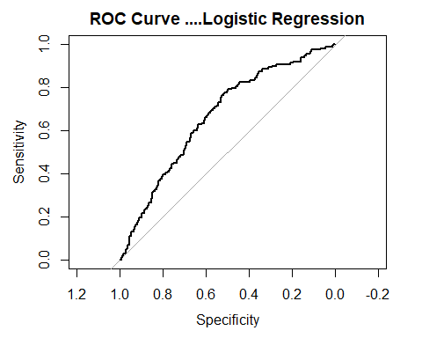
ysense <- roc1$sensitivities
xspec <- roc1$specificities
rocdat <- cbind(ysense, xspec)
rocdat <- as.data.frame(rocdat)
ggplot(rocdat, aes(x =(1-xspec), y =ysense)) +geom_line()
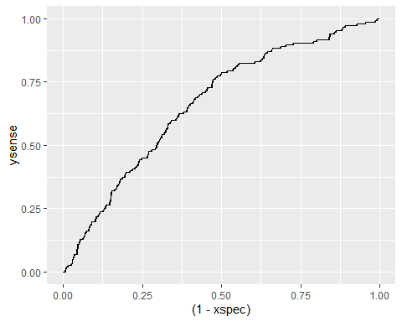 ## Random Forest
library(randomForest)
## randomForest 4.7-1.1
## Type rfNews() to see new features/changes/bug fixes.
##
## Attaching package: 'randomForest'
## The following object is masked from 'package:ggplot2':
##
## margin
## The following object is masked from 'package:dplyr':
##
## combine
set.seed(101)
uisdat$DFREE <- as.factor(uisdat$DFREE)
rf1<-randomForest(DFREE~ Age+BECK+IVHX+NDRUGTX+Race+Treat+Site,data= uisdat, importance=TRUE, ntree=500)
print(rf1)
##
## Call:
## randomForest(formula = DFREE ~ Age + BECK + IVHX + NDRUGTX + Race + Treat + Site, data = uisdat, importance = TRUE, ntree = 500)
## Type of random forest: classification
## Number of trees: 500
## No. of variables tried at each split: 2
##
## OOB estimate of error rate: 25.57%
## Confusion matrix:
## 0 1 class.error
## 0 419 9 0.02102804
## 1 138 9 0.93877551
#Evaluate variable importance
importance(rf1)
## 0 1 MeanDecreaseAccuracy MeanDecreaseGini
## Age 1.161185 -2.7344900 -0.4037873 43.254068
## BECK -1.311449 -0.2013367 -1.1532765 47.968803
## IVHX 5.328993 -2.5962526 3.5940130 11.332356
## NDRUGTX -0.792480 3.0135679 0.9138361 31.495914
## Race 2.209318 3.8193262 4.0366137 7.991328
## Treat -1.395301 -1.3573016 -1.8543121 7.040770
## Site -6.826309 3.4349262 -4.0608899 7.013897
varImpPlot(rf1)
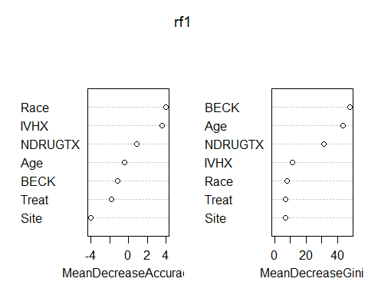 ## Prediction using Random Forest
library(ROCR)
##
## Attaching package: 'ROCR'
## The following object is masked from 'package:performance':
##
## performance
pred1 <- predict(rf1)
pred1
## 1 2 3 4 5 6 7 8 9 10 11 12 13 14 15 16 17 18 19 20
## 0 0 0 0 0 0 0 0 0 0 0 0 0 0 0 0 0 0 0 0
## 21 22 23 24 25 26 27 28 29 30 31 32 33 34 35 36 37 38 39 40
## 0 0 0 0 0 0 0 0 0 0 0 0 0 0 0 0 0 0 0 0
## 41 42 43 44 45 46 47 48 49 50 51 52 53 54 55 56 57 58 59 60
## 0 0 0 0 1 0 0 0 0 0 0 0 0 0 0 0 0 0 0 0
## 61 62 63 64 65 66 67 68 69 70 71 72 73 74 75 76 77 78 79 80
## 0 0 0 0 0 0 0 0 0 0 0 0 0 0 0 0 0 0 0 0
## 81 82 83 84 85 86 87 88 89 90 91 92 93 94 95 96 97 98 99 100
## 0 0 0 0 1 0 0 0 0 0 0 0 0 0 0 0 0 0 0 0
## 101 102 103 104 105 106 107 108 109 110 111 112 113 114 115 116 117 118 119 120
## 0 0 0 0 0 0 0 0 0 0 0 0 0 0 0 0 0 0 0 0
## 121 122 123 124 125 126 127 128 129 130 131 132 133 134 135 136 137 138 139 140
## 0 1 0 0 0 0 0 0 0 0 0 0 0 0 0 0 0 0 0 0
## 141 142 143 144 145 146 147 148 149 150 151 152 153 154 155 156 157 158 159 160
## 0 0 0 0 0 0 0 0 0 0 0 0 0 0 0 0 0 0 1 0
## 161 162 163 164 165 166 167 168 169 170 171 172 173 174 175 176 177 178 179 180
## 0 0 0 0 0 0 0 0 0 0 0 0 0 0 0 0 0 0 0 0
## 181 182 183 184 185 186 187 188 189 190 191 192 193 194 195 196 197 198 199 200
## 0 0 0 0 0 0 0 0 0 0 1 0 0 0 0 0 0 0 0 0
## 201 202 203 204 205 206 207 208 209 210 211 212 213 214 215 216 217 218 219 220
## 0 0 0 0 0 0 0 0 0 0 0 0 0 0 0 0 0 0 0 0
## 221 222 223 224 225 226 227 228 229 230 231 232 233 234 235 236 237 238 239 240
## 0 0 0 0 0 0 0 0 0 0 0 0 0 0 0 0 0 0 0 0
## 241 242 243 244 245 246 247 248 249 250 251 252 253 254 255 256 257 258 259 260
## 0 0 0 0 0 0 0 0 0 0 0 0 0 0 0 0 0 0 0 0
## 261 262 263 264 265 266 267 268 269 270 271 272 273 274 275 276 277 278 279 280
## 0 0 0 0 0 0 0 0 0 0 0 0 0 0 0 0 0 0 0 0
## 281 282 283 284 285 286 287 288 289 290 291 292 293 294 295 296 297 298 299 300
## 0 0 0 0 0 0 0 0 0 0 0 0 0 0 0 0 0 0 0 0
## 301 302 303 304 305 306 307 308 309 310 311 312 313 314 315 316 317 318 319 320
## 0 0 0 0 0 0 0 0 1 0 0 0 0 0 0 0 0 0 0 0
## 321 322 323 324 325 326 327 328 329 330 331 332 333 334 335 336 337 338 339 340
## 0 0 0 0 0 0 0 0 0 0 0 0 0 0 0 0 0 1 0 0
## 341 342 343 344 345 346 347 348 349 350 351 352 353 354 355 356 357 358 359 360
## 0 0 0 0 0 0 0 0 0 0 0 0 0 0 0 0 0 0 0 0
## 361 362 363 364 365 366 367 368 369 370 371 372 373 374 375 376 377 378 379 380
## 0 0 0 0 0 0 0 0 0 0 0 0 0 0 0 0 0 0 0 0
## 381 382 383 384 385 386 387 388 389 390 391 392 393 394 395 396 397 398 399 400
## 0 0 0 0 0 0 0 0 0 0 0 0 0 0 0 0 0 1 0 0
## 401 402 403 404 405 406 407 408 409 410 411 412 413 414 415 416 417 418 419 420
## 0 0 0 0 0 0 0 0 0 0 0 0 1 0 0 0 0 0 0 0
## 421 422 423 424 425 426 427 428 429 430 431 432 433 434 435 436 437 438 439 440
## 0 0 0 0 0 0 0 0 1 0 0 0 1 1 0 0 0 0 0 0
## 441 442 443 444 445 446 447 448 449 450 451 452 453 454 455 456 457 458 459 460
## 0 0 0 0 0 0 0 0 1 0 0 0 0 0 0 0 0 0 0 0
## 461 462 463 464 465 466 467 468 469 470 471 472 473 474 475 476 477 478 479 480
## 0 0 0 0 0 0 1 0 0 0 0 0 0 0 0 0 0 0 0 0
## 481 482 483 484 485 486 487 488 489 490 491 492 493 494 495 496 497 498 499 500
## 0 0 0 0 0 0 0 0 0 0 0 0 0 0 0 0 0 0 0 0
## 501 502 503 504 505 506 507 508 509 510 511 512 513 514 515 516 517 518 519 520
## 0 0 0 0 0 0 0 0 0 0 0 0 0 0 1 0 0 0 0 0
## 521 522 523 524 525 526 527 528 529 530 531 532 533 534 535 536 537 538 539 540
## 0 0 0 0 0 0 0 0 0 0 0 0 0 0 0 0 0 1 0 0
## 541 542 543 544 545 546 547 548 549 550 551 552 553 554 555 556 557 558 559 560
## 0 0 0 0 0 0 0 0 0 0 0 0 0 0 0 1 0 0 0 1
## 561 562 563 564 565 566 567 568 569 570 571 572 573 574 575
## 0 0 0 0 0 0 0 0 0 0 0 0 0 0 0
## Levels: 0 1

Cross_Classification
table(pred1, uisdat$DFREE)
##
## pred1 0 1
## 0 419 138
## 1 9 9

Prediction
predictions <- predict(rf1, type="prob")
pred <- prediction(predictions[,2], uisdat$DFREE)
perf <- performance(pred, measure ="tpr", x.measure ="fpr")
plot(perf)
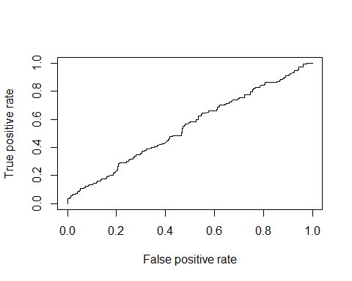 ## Area under curve
library(ROCR)
auc <- performance(pred, measure = "auc")
print(auc@y.values)
## [[1]]
## [1] 0.5461568

Plot the ROC curve
plot(perf,main="ROC Curve for Random Forest",col=2,lwd=2)
abline(a=0,b=1,lwd=2,lty=2,col="gray")
